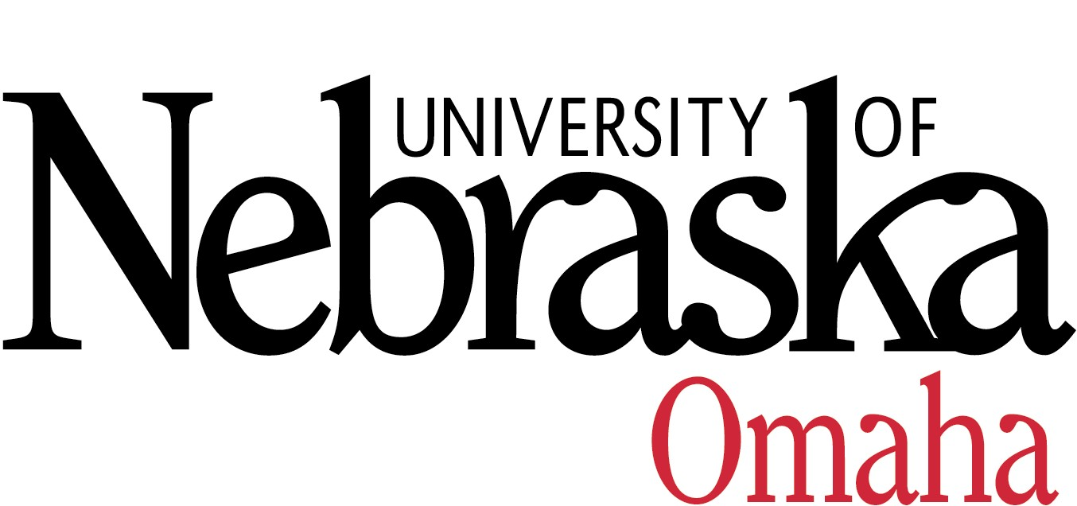_____________________________________________________________________________________________
ACADEMIC AFFAIRS

FACULTY EXCELLENCE IN ENGAGEMENT AWARD

Overview
The Faculty Excellence in Engagement Award recognizes excellence in global or community engagement by UNO faculty. Global engagement refers to the myriad ways faculty work to connect UNO to the world through their teaching, research and creative activity, and service. UNO defines community engagement as the “collaboration between the University and its local, regional, national and global communities for the exchange of knowledge and resources." Nominations should be for one of the two categories (global or community engagement), however, faculty can be nominated separately for each category.

The award will consider the faculty member’s record of engagement at UNO.

Evaluation Criteria

- Global Engagement:
Excellence in global engagement will be evaluated according to the criteria listed below:
- Teaching: Outstanding global engagement through teaching activities (e.g., study abroad programs, internationalization of the curriculum, teaching international courses).
- Research and Creative Activity: Outstanding global engagement through research or creative activities (e.g., publications, presentations, and grants supporting international initiatives).
- Service: Excellence in service activities in support of global engagement (e.g., on campus activities, community activities).

- Community Engagement
Excellence in community engagement will be evaluated according to the criteria listed below:
- The nomination contains evidence that the nominee’s engaged work has benefitted individuals, families, and/or external communities, as well as students.
- The nomination affirms that the engaged work occurred as a result of reciprocal, mutually beneficial collaboration between the nominee and external community(s).
- The nomination demonstrates that the nominee’s engaged work has resulted in contributions to scholarship that have been recognized by a community of scholars in the field of study.
- The nomination documents the short and long-term impact of the nominee’s engaged work on the targeted community(s).

Note: Service learning is a recognized form of engaged teaching at UNO. The Faculty Service Learning Award recognizes faculty excellence in this regard. Faculty with exceptional records of service learning may be nominated for the Excellence in Community Engagement Award; however, all four criteria related to engaged scholarship should be addressed in the application.

Nomination and Application Information
The Faculty Excellence in Engagement Award application consists of a nomination form and nomination materials, all of which are due electronically on the following dates:
- Nomination form: March 1, 2024
- Nomination materials: April 1, 2024

Eligibility and Nomination Form
All full-time UNO faculty are eligible to be nominated. The nomination form (below) may be completed by a full-time faculty member or the nominee’s Department Chair/School Director and should designate. Please note, however, that faculty cannot nominate themselves. Nomination materials will be reviewed by the Faculty Excellence in Engagement Award Committee. Nominations are valid for three years.

All applications should include the following:
- Personal statement by the nominee describing how they have a sustained record of excellence in either global or community engagement. The personal statement should be no longer than 2-3 pages, single-spaced.
- Current CV with complete information and with engagement activities highlighted or bolded.
- Letter of nomination by the Department Chair, School Director, or a UNO full-time faculty member.
- At least two letters of support, but no more than five, should be submitted. Letters can be from colleagues, students, or global/community partners. The letters should speak to the aforementioned criteria and provide a sense of the impact of the nominee’s work with regard to engagement. Letters should be sent to the Faculty Excellence in Engagement Award Committee at facengagementaward@unomaha.edu
Application materials must be received electronically by April 1, 2024, for full consideration by the Faculty Excellence in Engagement Award Committee. Submit files digitally to facengagementaward@unomaha.edu. Contact Julie Dierberger, Ph.D., Chief Engagement Officer, UNO Office of Engagement, at jdierberger@unomaha.edu (402-554-3268) for questions about the community engagement category or Jody Neathery-Castro, Ph.D., Associate Vice Chancellor for Global Engagement at jneathery@unomaha.edu (402-554-2293) for the global engagement category.

FACULTY EXCELLENCE IN ENGAGEMENT AWARD
2023-24 Nomination Form - Due March 1, 2024

All full-time UNO faculty are eligible to be nominated. The nomination form (below) may be completed by a full-time faculty member or the nominee’s Department Chair/School Director. Please note, however, that faculty cannot nominate themselves.

Name of Nominee:

Rank:

Department:

Name of Nominator:

Relationship to Nominee (e.g., student in class, seminars, or other form of instruction; advisee, colleague, etc.)

Engagement category for which the faculty member is being nominated (note: one category per nomination)

______________Global Engagement __________________ Community Engagement

Full application packets must be received electronically by April 1, 2024, for full consideration by the Faculty Excellence in Engagement Award Committee. Submit files digitally to facengagementaward@unomaha.edu. Contact Julie Dierberger, Ph.D., Chief Engagement Officer, UNO Office of Engagement, at jdierberger@unomaha.edu (402-554-3268) for questions about the community engagement category or Jody Neathery-Castro, Ph.D., Associate Vice Chancellor for Global Engagement at jneathery@unomaha.edu (402-554-2293) for the global engagement category.

