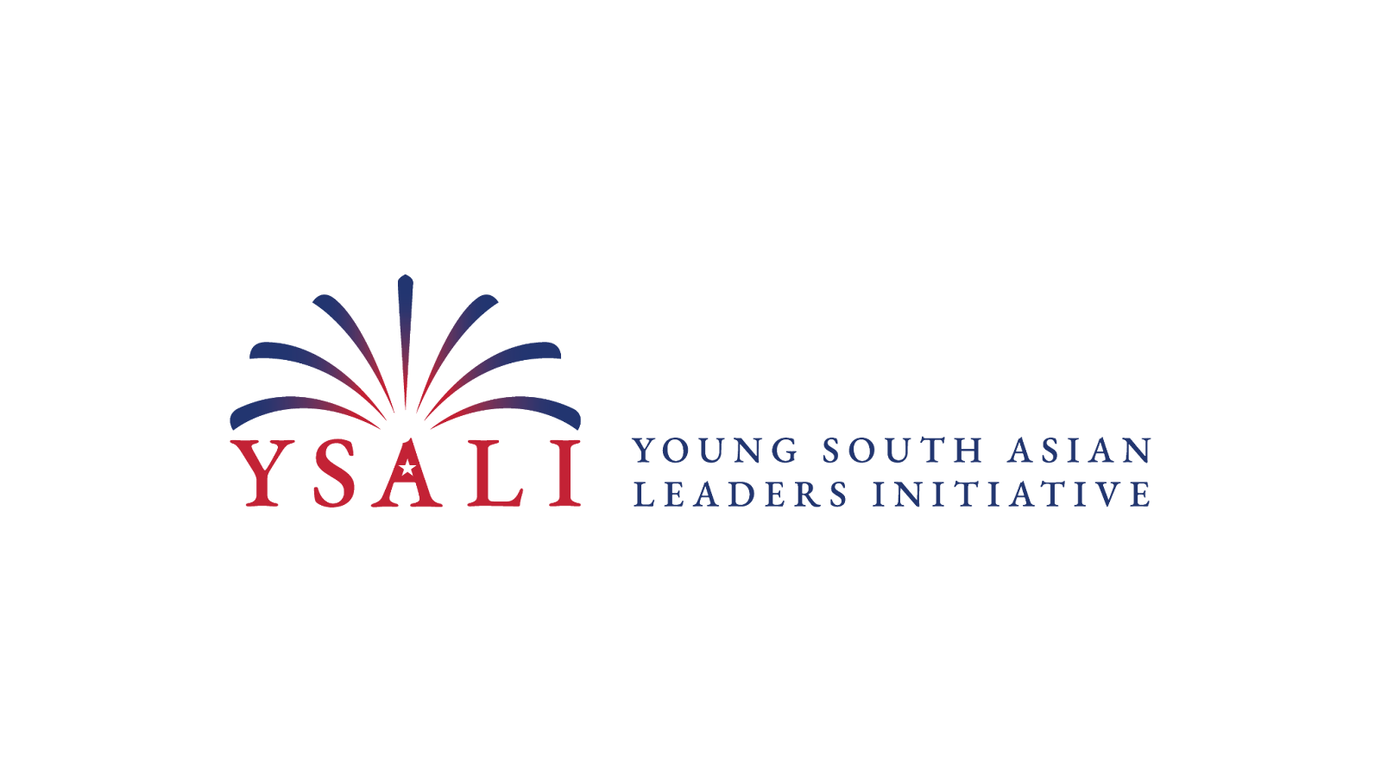

1. What is the YSALI Program?
YSALI (Young South Asian Leaders Initiative) is a program designed to promote leadership, exchange ideas, and foster collaboration between young leaders from South Asia and the United States. It typically focuses on young South Asian professionals and entrepreneurs who are looking to enhance their leadership skills, learn about U.S. business practices, and develop skills that can contribute to their communities and countries.
2. Do I need to pay for the program? What are the costs?
The YSALI program is usually fully funded, meaning participants do not have to pay for most of the associated costs. This can include travel expenses, accommodation, meals, and program-related activities. However, it’s always best to check the specific program details for the year you’re applying to, as policies can sometimes change.
3. What currency should I use in Sri Lanka?
The official currency is the Sri Lankan Rupee (LKR). It's recommended to exchange some money before you travel, but ATMs are widely available in cities.

4. How can I get around Sri Lanka?
Public transport options include buses, trains, tuk-tuks, and taxis. Trains are a scenic way to travel, especially in the hill country. Tuk-tuks are great for short trips in the cities, but always agree on a price before you hop in. Ride-hailing apps like PickMe and Uber also operate in major cities.
5. Is it safe to use public transportation?
Public transportation is generally safe, but be mindful of your belongings, especially in crowded areas.

6. Is Sri Lanka safe for young travelers?
Sri Lanka is generally safe for tourists, but like in any country, basic safety precautions should be followed, such as keeping an eye on personal belongings and avoiding risky areas at night.

7. Do I need any vaccinations before visiting?
While there are no mandatory vaccinations, it's advisable to be up to date on general vaccinations (like hepatitis A, typhoid, and malaria prevention) before traveling to Sri Lanka.

8. What should I do in case of an emergency?
Familiarize yourself with emergency contact numbers. The general emergency number in Sri Lanka is 119 for police. For ambulance, fire, and rescue, dial 110.

9. When will I be notified if selected? What will be covered if I am able to attend?
You will be notified of the results of your application and which sessions you have been selected to facilitate by mid-February 2025. Round Trip flights to/from Colombo, ground transportation, accommodation and some meals will be covered

10. Will the organizers help me arrange an earlier arrival or later departure from the workshop?
No. Organizing an experiential workshop of this size is an immense task. Therefore, we unfortunately cannot support participants seeking to customize their itinerary.
11. Can I bring family, friends, or other dependents?
Unfortunately, NO. Family, friends, and other dependents will not be able to join.
12. Can I work remotely during the workshop and only attend a few sessions?
No. An experiential workshop will require you to be active and engaged in all activities, even leading some of your own sessions from sun-up to sun-down and evenings too!
13. Can I join late or leave early due to work or other commitments?
No. You must be available for the entire duration of the workshop.
14. Will I need a visa to attend the workshop?
Yes, most South Asian countries require a visa to enter Sri Lanka. However, citizens from countries such as India, Nepal, and Bhutan can enter Sri Lanka with just an Electronic Travel Authorization (ETA), which is usually easy to apply for online.
The YSALI organizers will usually provide detailed instructions on the visa application process if you are selected, including any support for acquiring the necessary documentation.
15. How do I apply for an ETA?
You can apply for an ETA on the official Sri Lanka government website. Select the "business short term" category. It's a quick process, but ensure you apply well in advance.
16. Will transportation be provided from the airport to the hotel and how will I find out who is arranging that?
Arrival: Upon your arrival at Bandaranaike International Airport (CMB), our transportation team will be waiting at the arrivals area with a signboard displaying the workshop name.

- Please ensure that you share your flight details and updates with the organizing team at least two weeks before your travel.
- Departure: On the final day of the workshop, transportation will be arranged from the hotel to the airport.
- You will receive your pick-up schedule the day before departure.

17. What happens after the program?
After the program, participants often stay engaged in alumni activities, including networking events, leadership development opportunities, and follow-up programs. You may also be expected to share what you’ve learned with others in your community or professional network. The idea is to keep fostering the leadership impact you gained from the exchange. Your online Canvas class will remain active for 6 months after the regional workshop. There will be some follow-up programming announced to you on Canvas and you will be able to keep in touch with your instructors and mentors there.
18. I have a question that was not answered. Who should I contact to find an answer?
For all additional questions about the workshop, please email ysaliuno@unomaha.edu

